

MGSC 672: Operations and Supply Chain Analytics
Case Study #1: Fashion: Art vs. Science Analysis

Submitted to:
Professor Saibal Ray

Submitted by:
Group 4
Luice Peccoux | 261087292
Julie Chanzy | 261077392
Priyanka Jahul | 261076605
Emery Dittmer | 260658030
Sunny Wu | 261102578
Michael Murphy | 261060598

May 17th, 2023

Executive Summary
Flashion, a quick-sale fashion company, is encountering growth difficulties in a shrinking industry. A new employee, Wilson, identifies the current pricing models as a significant obstacle that leads to inconsistent sell-through rates and excessive manual work. The related pain points that restrict the growth of Flashion include inaccurate inventory foresight, supply chain control, first exposure item pricing uncertainty, the inapplicability of traditional pricing models, the internal resistance of change to data-driven approaches, lack of valuable data collection, inefficient pricing comparison with competitors, as well as defining the right objectives and level of aggregation.
The recommended approach is transitioning from the current buyer-driven intuition approach to a data-driven pricing strategy to optimize the current pricing model. This shift entails leveraging internal and external data to automate the price determination. However, the corresponding challenges and limitations, such as internal stakeholder resistance and limited data availability, must be carefully evaluated before moving to the implementation plan. The expected outcome of implementing the suggested model is enhanced efficiency, uniform sell-through rate, reduced manual work, decreased inventory cost, and improved overall operational effectiveness. By embracing a data-driven methodology, Flashion would break through the current growth challenges, gain a competitive edge in the industry, and establish a sustainable business model.
The subsequent sections of this case study will dive deep into the comprehensive problem analysis, the recommended solution approach, the implementation plan, the potential impact assessment, and the approach’s limitations evaluation.

Problem Presentation & Analysis
The problem with this use case is the lack of a pricing strategy. There is no repeatable or reliable determined process to set the price of an item for an event. When setting the price on the website, the buyers consider the negotiated buying price from the retailers and a margin. Still, the final decision is based on their market knowledge and experience. In other words, the prices are mostly set intuitively. This methodology is a hit for some products or items, but during other events, not all the stock is “sold through”. In this case, Flashion would lose money over inventory and the storage of unsold items until the next event.

This methodology has been used at Flashion since the beginning and was never questioned until recently. As the annual industry growth rate is declining, and this market is turning into a more and more red ocean, Flashion’s leaders want to optimize the price to maximize the revenue and sell through while not compromising their business promises. Indeed, based on historical sales, some items reached the “sell-through” objective of 80% or a full “sell-through” quickly, suggesting that the price could have been higher. Other products did not reach 80% sell-through, meaning that the price may have been too high, leading to lower demand and excess inventory.

To address this problem, Flashion wants to develop a more data-driven approach to pricing. This would involve analyzing historical sales data and forecasting the demand for each type of similar item to establish pricing guidelines for buyers. The goal is to achieve 80% "sell-through" for all events while maintaining competitive prices. Flashion must access internal and external data sources to implement this new approach. These may include data on the type of items, categories, or subcategories showcased in Exhibit 2, the quantity bought and sold, price, margin, seasonality, brand, and sales duration for internal data. However, obtaining competitor pricing information is challenging due to the high variety of products and naming differences.

Nevertheless, this approach has two significant drawbacks, which Flashion will have to consider. The first one is the high variety of products and the fact that most events showcase items that have never been seen on the website before, making the demand forecasting and price setting more complex. The second one is the resistance to change from the buyers. Indeed, not all buyers are happy to see some of their responsibilities taken away and their expertise questioned or challenged.

Detailed Recommendations & Impact
Wilson will want to tackle the pricing model challenge at the core of Flashion’s business model. Flashion promises the lowest clothing prices while retaining margins on its sales. Flashion relies on its pricing model for its competitive advantage, meaning that optimization of the model has high stakes and impacts the business. A pricing model that automatically generates pricing for the buyers to review would free up time for buyers, grow the business and ensure that the pricing is, in fact, the lowest. The scale of this product is enormous, but Wilson may be able to plan strategically to have a high impact (see Figure 1 for approach).

First, Wilson will need to discover and plan. During this phase, Wilson will collect the available data, plan an approach, and estimate the impact of her improvements. For this approach, she should identify any commonalities between A, B, and C-type assets as the A-type assets represent around 80% of revenue from only 20% of the SKUs. The A-type items are key for a high impact with less computational time. Wilson should research pricing models, as competitor data or other estimates may help with the impact measurement. To close off the discovery phase, Wilson must identify existing data, the data gaps, and the inventory cost to build a Proof of Concept (POC) strategy. Next, she will need a formal project sponsor before pitching her proposal to the executive board. The mentorship of an involved executive will allow faster and more concrete progress and regular feedback while tackling internal resistance and lack of prioritization.

Wilson will then need to start an in-depth analysis. She will need to identify the factors and appropriate model types that affect the price of an item, the desired prediction level, and which products to predict using the A, B, C type methodology. For instance, what are the relationships between product lines, trends, seasonality, product features, time on the web page, and the cannibalization of other products in the same event? Once Wilson has the primary factors that drive price, she must determine the aggregation level she intends to use. A more granular approach may be better from a planning perspective, however, for this analysis, Wilson should estimate at a style level (see figure 2). Flashion receives a variety of styles without notice planning at anything more profound than the style level would prove fruitless from a buyer and analyst perspective.

Once Wilson has identified the factors that most contribute to price, she will need to present a proof of concept (POC) model for pricing, applied to selected items to compare it to the baseline intuition-driven strategy (see figures 3 & 4 for feature importance). The POC should be validated against historical performance and predicted on select styles to limit the impact on the business. At this point, the project sponsor plays a key role in objectively identifying POC elements in and out of scope and helps ensure a more accurate MSRP comparison.

Once developed, the POC framework will be helpful for Flashion to benchmark its sell-through models. While the current model is based on intuition, a data-driven approach may prove more robust. Based on key success stories, we estimate an increase in fashion revenue between 0%-10%. In 2008, the fast fashion multinational company Zara experimented with markdown strategies on multiple items. The model produced a 6% or $90M increase in sales revenue.¹ Academic research argues that bureaucratic and non-data-driven pricing is often sub-optimal and results in lost revenue.² The most consistent and performing model, intuition or data analytics will be the one that Flashion should rely on.

Finally, a data-driven approach would allow us to identify and follow key performance indicators. This will benefit the company on the long run by providing a monitoring tool for future understanding and analysis of Flashion’s products, therefore equipping buyers with insightful trends and figures to improve their decision-making process (see Figure 1 for the implementation roadmap).

Limitations
The limitations of our approach begin with the pricing strategy for first time exposure styles. Implementing a pricing strategy for new items with no historical data will require proxying price data from other products with similar characteristics, whether competitors’ products or Flashion itself. General producing price comparisons are possible, however, automating more price collection for more relevant proxies will prove challenging due to the unique naming conventions. Without a standard naming convention, SKU number or another unique id it is impossible to compare items 1 to 1 for a price reference.
The pricing strategy implemented is likely to be a single-price static model as changing the price throughout such short events would disrupt the brand integrity and lead customers to learn the discounting patterns. Consumers would likely delay purchases until the end of the sale to save the most. The restriction on one price limits pricing models as it will be difficult to drive customer demand for underperforming products without adjusting the price during the event.
The best approach for Flashion may be to come up with a demand prediction for an item based on static pricing. With the demand model, the price is optimized to sell through thus inventory management could be improved and sell-through rates above 80% on all products is feasible. With the demand prediction the team should focus on their “A” products meaning that they can focus on having sufficient inventory for 20% of their products that bring in around 70-80% of revenue. An 80% sell-through rate for all products may not be achievable, however, knowing which products the A-type are is crucial to improve business performance.

References
(1) Talluri, K.; Van Ryzin, G. Revenue management under a general discrete choice model of consumer behavior. Management Science 2004, 50 (1), 15-33.
(2) Wood, S.; Watson, I.; Teller, C. Pricing in online fashion retailing: implications for research and practice. Journal of Marketing Management 2021, 37 (11-12), 1219-1242.

Appendix
The appendix below groups all figures referenced in the above text.
Additional analysis and source for figures can be found in the accompanying python notebook file titled: MGSC 672 - Group 4 - Operations & Supply Chain - Analysis of Flashion Case Code

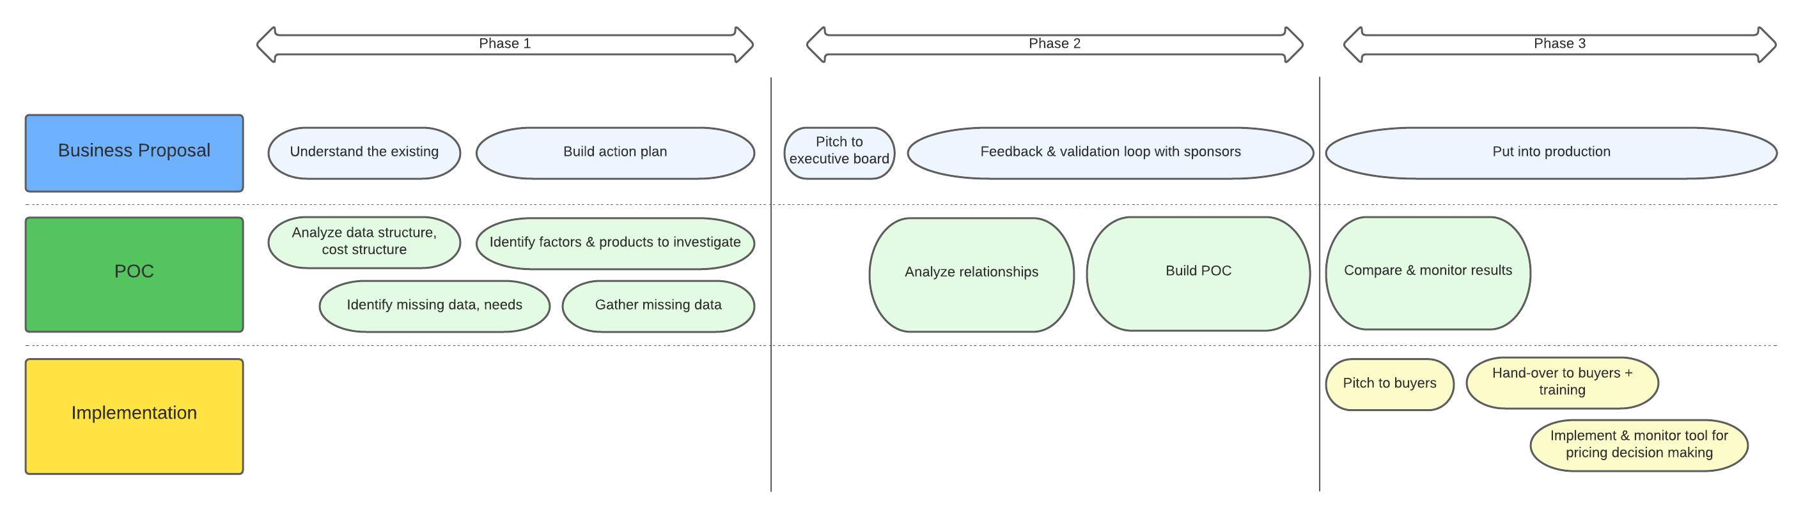
Figure 1:Wilson’s roadmap to carry out data-driven pricing project at Flashion’s

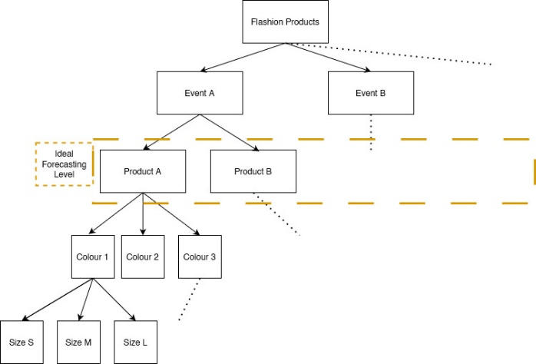
Figure 2: Granularity levels of data for Flashion’s events with recommended prediction granularity

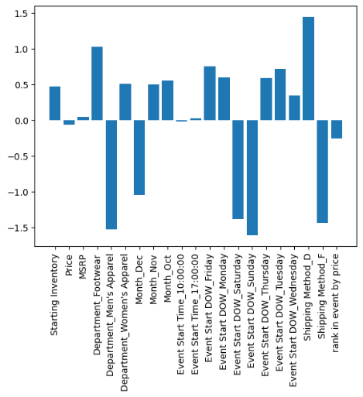
Figure 3: Feature Importance Based on Linear Regression with no Scaling and all Dummified Data. Importance Denoted as Deviation from 0.
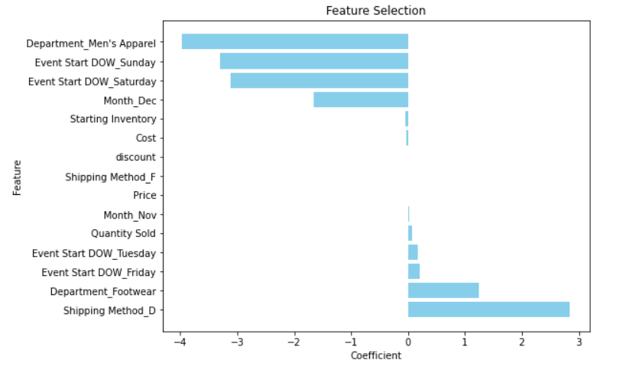
Figure 4: Feature Importance Based on LASSO Modeling. Importance Denoted as Deviation from 0.

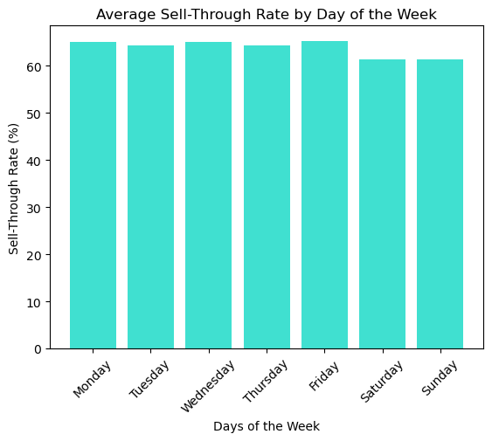
Figure 5: Day of the Week Effect on Average Sell Through rate at Flashion. No significant Day of Week Noted
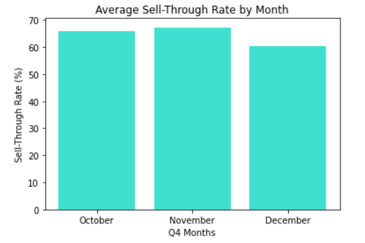
Figure 6: Month Effect on Average Sell Through Rate at Flahion. No significant trends Detected.
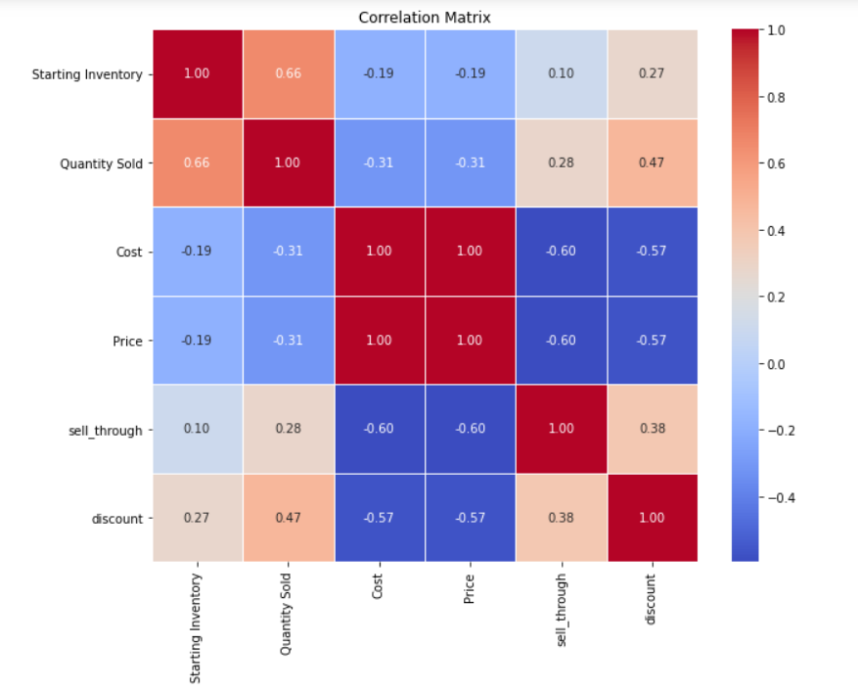
Figure 7: Correlation Matrix on Numeric Factors. Correlation of 1 indicates perfect correlation.

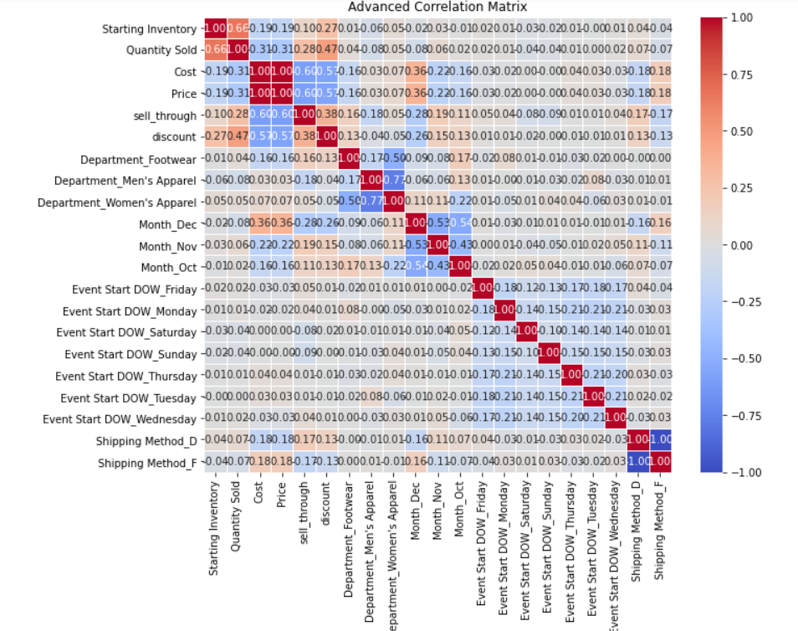
Figure 8: Correlation Matrix on All Factors of Sales. Dummified variables. Correlation of 1 indicates perfect correlation.

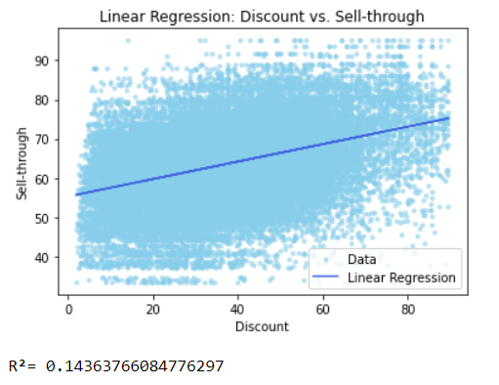
Figure 9: Scatter Plot of Sell-through Rate versus Product Discount. All Flashion Sales Data with Linear Regression.
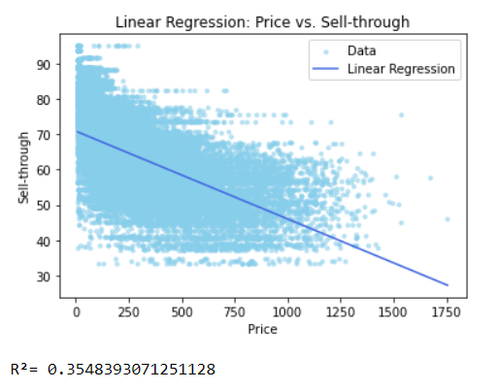
Figure 10:Scatter Plot of Sell-through Rate versus Product Price. All Flashion Sales Data with Linear Regression.

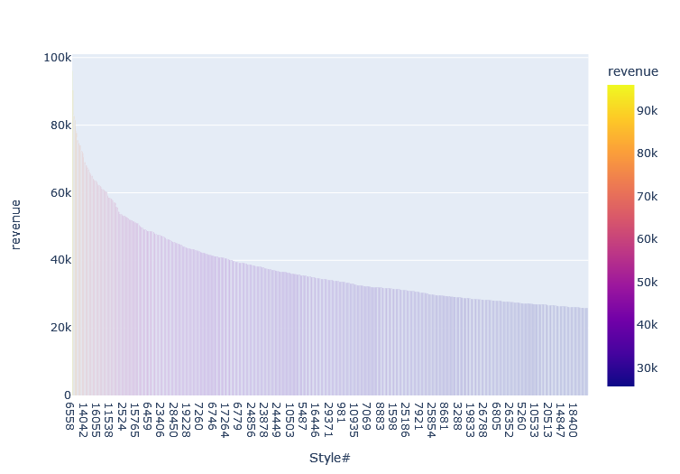
Figure 11: Distribution of top 1000 Styles Plotted in Descending Order. Demonstrates Exponentail Decay, Therefore Parateo Principle Likely.
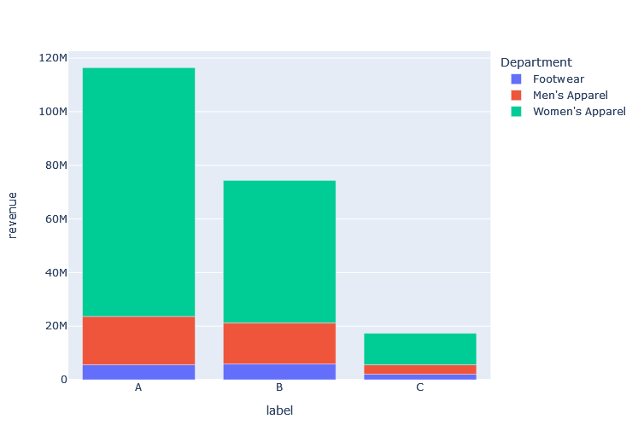
Figure 12: Distribution of A, B, and C Type Products by Revenue and Departement
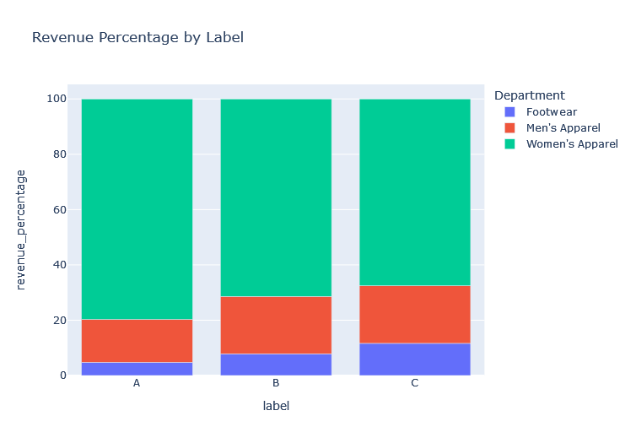
Figure 13: A,B, C type Product Revenue Plotted as % of Total for each Product Type.

